ASSIGNMENT NO. 02:

**Spring 2024**

**Signal & System**

Submitted by: **NAVEED AHMAD**

Registration No.: **22PWCSE2165**

Class Section: **B**

“On my honor, as student of University of Engineering and Technology, I have neither given nor received unauthorized assistance on this academic work.”

Submitted to:

**Dr. Nasir Ahmad**

24/05/2024.

Department of Computer Systems Engineering

University of Engineering and Technology, Peshawar

**Question 1**. *Find the Fourier series representation for the following signals and sketch their spectrums.*

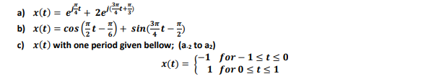

**Part(a):**

Solution:

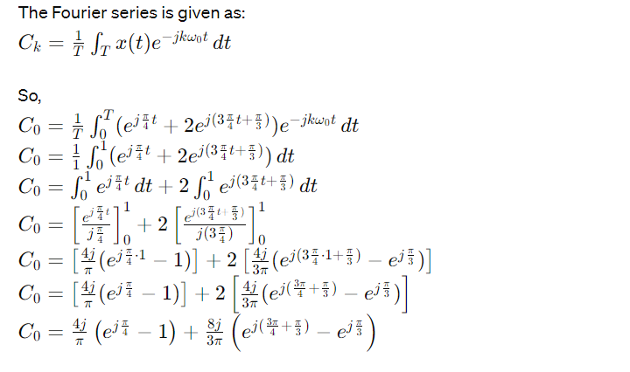

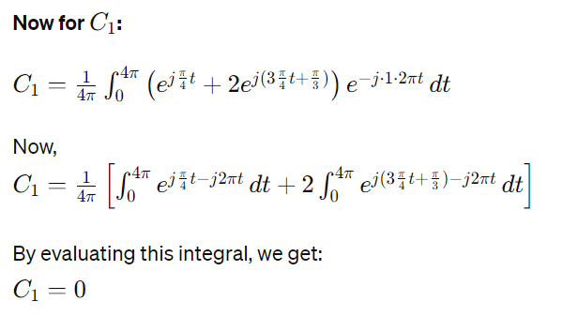

**Part(b):**

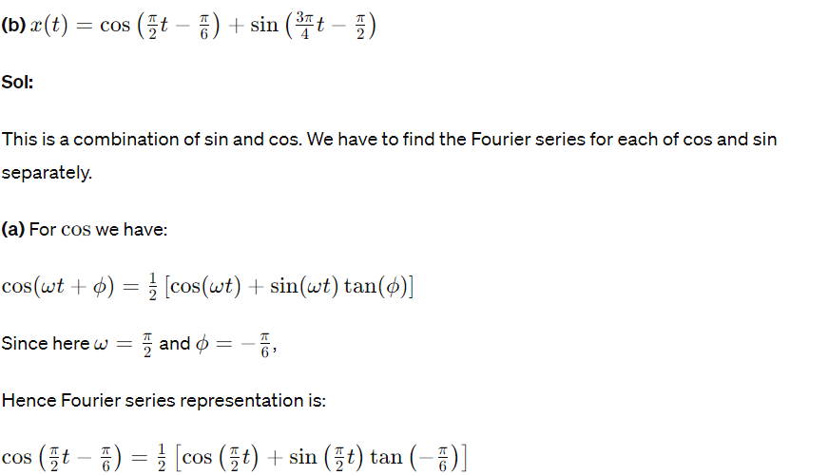

**Part(c):**

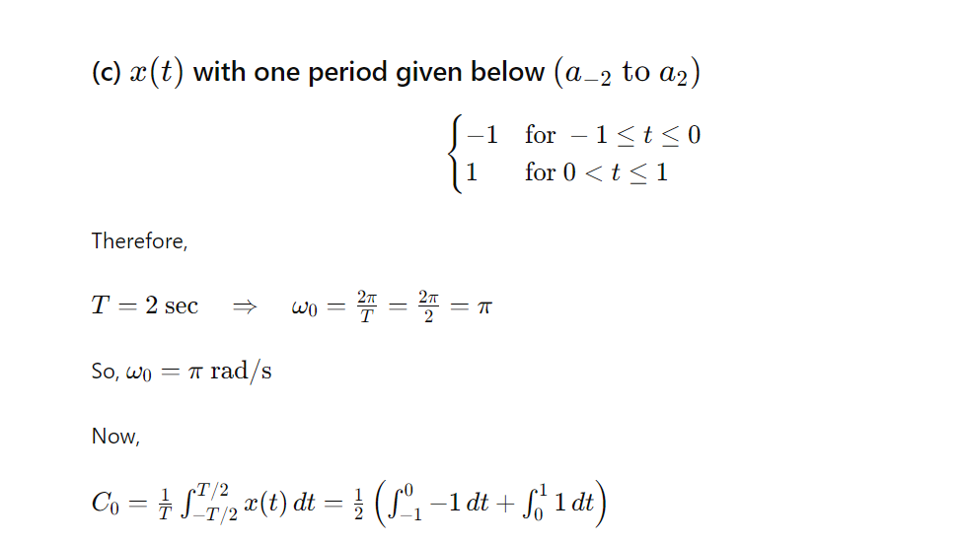

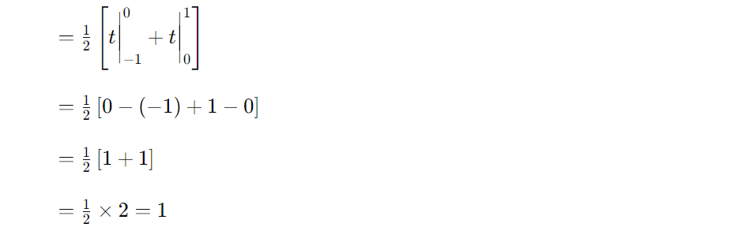

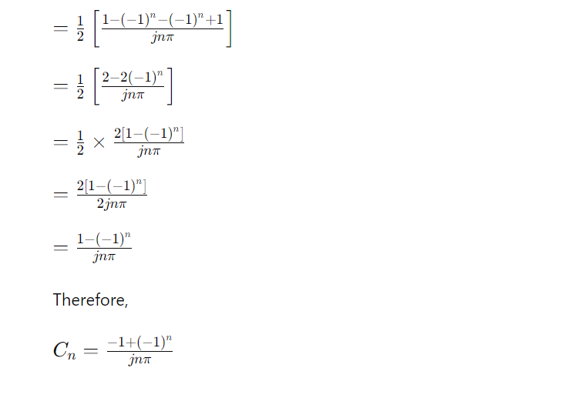

**Question 2. Find the Fourier series representation for the signals given in the following figure and sketch their spectrums. For continuous-time signals find the frequency components from a-3 to a3**

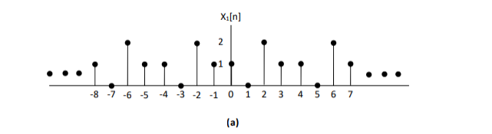

**Part(a):**

**Solution:**

**Spectrum:**

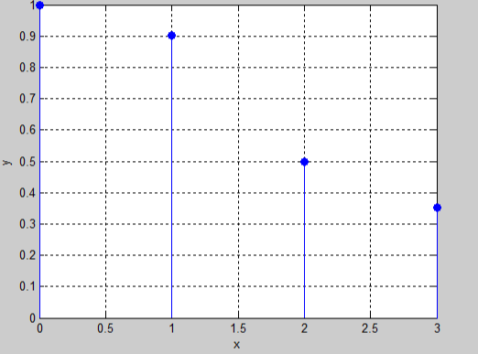

**Part(b):**

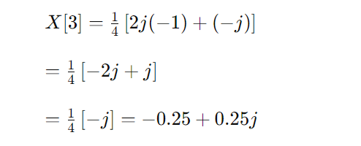

**Magnitude spectrum:**

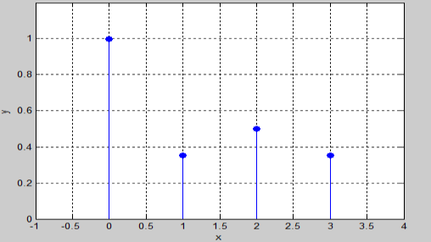

**Part(c):**

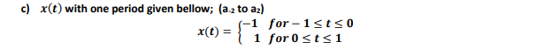

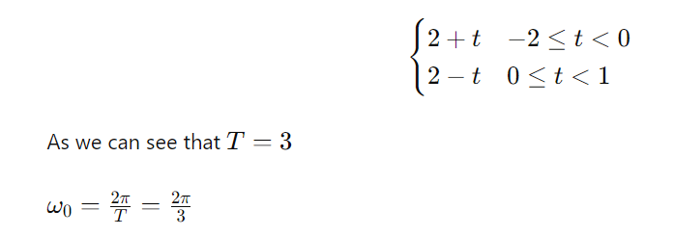

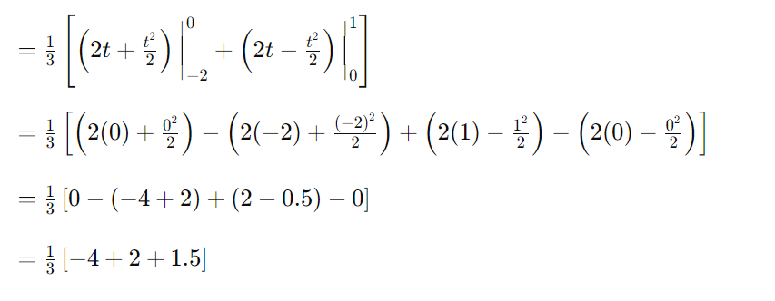

**Spectrum:**

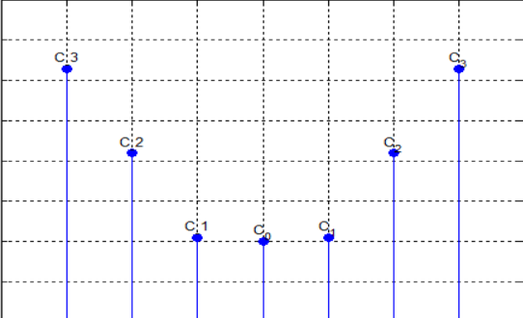

**Question No. 03:**

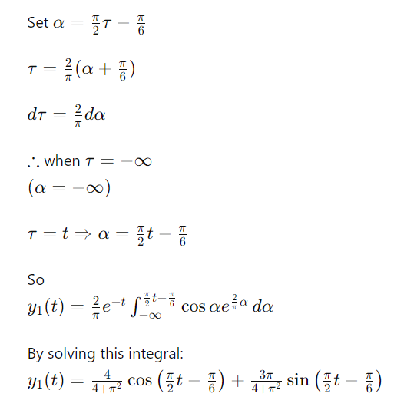

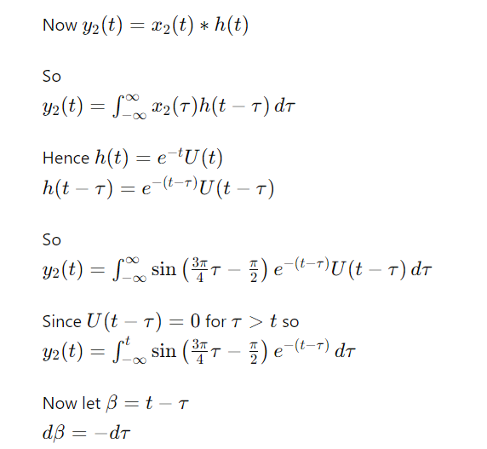

**THE END.**